**Luxury Retreats**

**Email Template Design**

**Dev Revisions May 24th**

**Alt A Test**

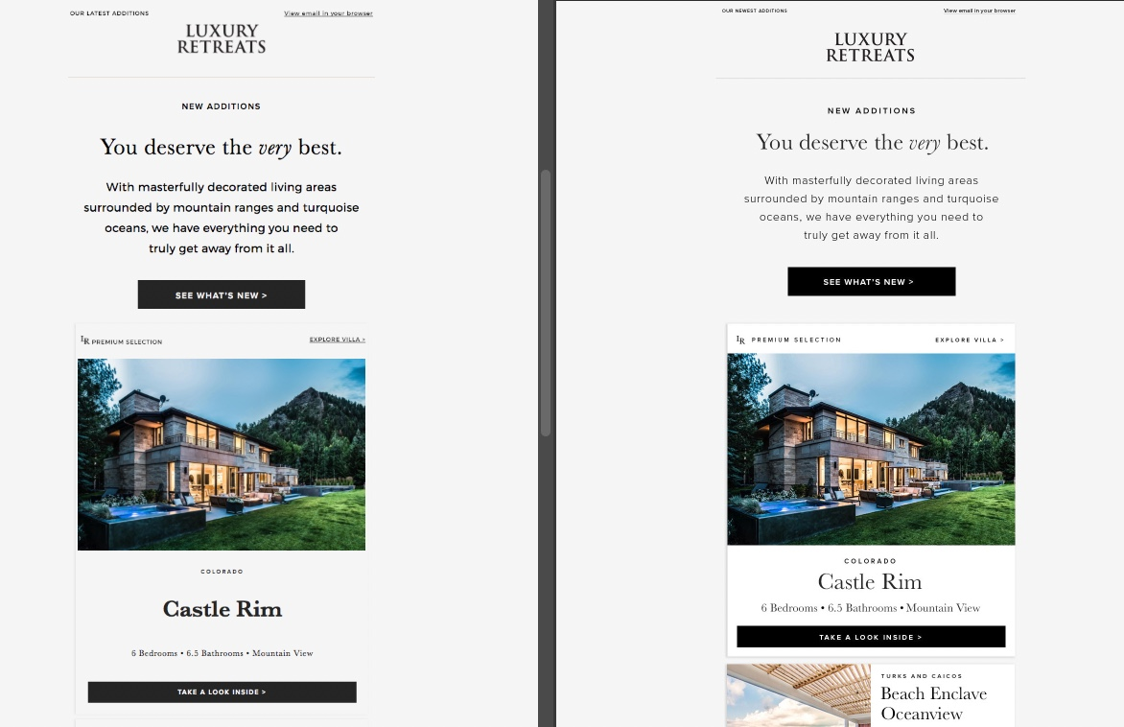

**Templates require polishing and must match psd templates without discrepancies.

Notes:

* Header
  + **More space above logo.** Distance at bottom and top should be equal.
  + **Pre header text skewed in inbox is skewed.** Appears fine on browser
* Header Mobile
  + More padding at top of logo
* Hero body text
  + **Fonts still present an issue.** Body is pulling Montserrat Regular. If Monserrat is being coded as back up font style, we need to pull Montserrat Light for body.
* Premium Selection Block
  + **Blocks should have a white background**
  + **Details need polishing.** 
    - Spacing is off between “LR” and “Premium Selection”
    - Lift baseline of Premium Selection to match psd
    - Increase letter spacing on Premium Selection to 3px
    - “Explore villas” should be semi bold, letter spacing 3px, no underline.
    - Villa name is pulling Baskerville Bold, should be Baskerville Regular
    - Too much space between lines of text. Refer to design file.
    - Shift baseline down 1 to 2 px on CTA button text
* Listing blocks
  + **Blocks should be white**
  + **Blocks should not be merged together.** Need to be separate. Please refer to design files.
  + **Details need polishing.** 
    - Elements are looking too piled together
    - Please review line heights and spacing between elements.
    - Images do not look property framed in blocks
    - Shift baseline up on text CTA so text is centered inside the block
* Listing mobile
  + - Villa name and features are too small. Need to match design files.
* Pre-footer
  + More space between last listing and pre-footer
  + Text needs to pull Montserrat Light not regular as back up
* Footer
  + Padding at top between icons and line. See design files.
  + Showing a double footer. Should not have any information under the LR icon

**Alt B + C Test**

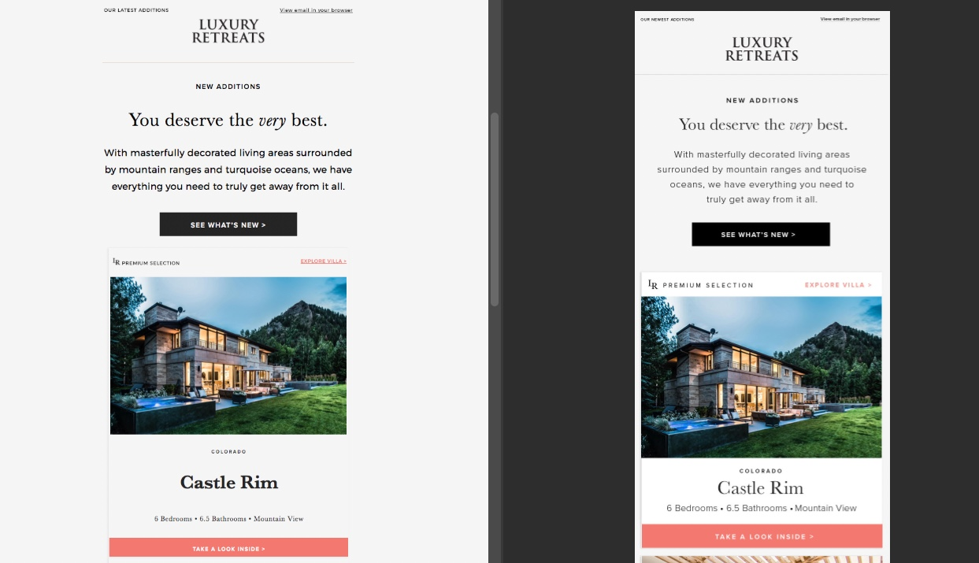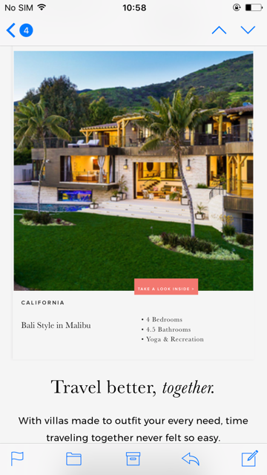

Notes are like Alt A.

White background on blocks, spacing issues with fonts, etc.

Mobile CTA buttons not performing well. All type elements need polishing.